Backend Node JS

Tool: We use node js and implement the backend to expose an API and connect to the database.

Step 1: we build our server.js on the local machine with the help of node js.

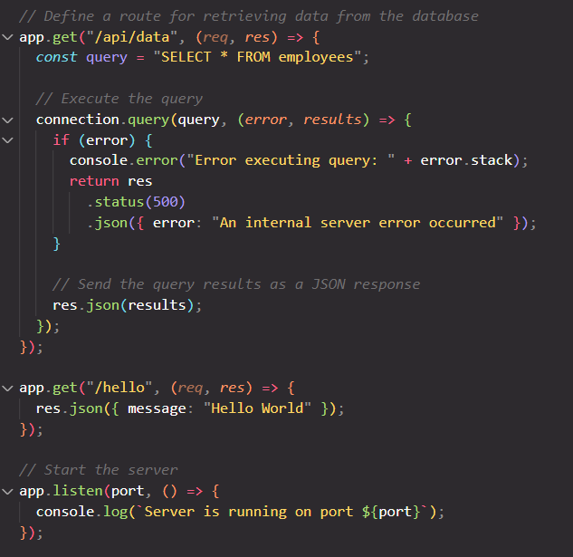

Step 2: Connect the backend with the database

Step 3: We copy the local file to the cloud server with the help of winscp

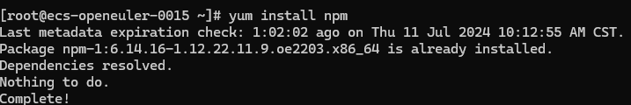Step 4: install the npm to run the node project

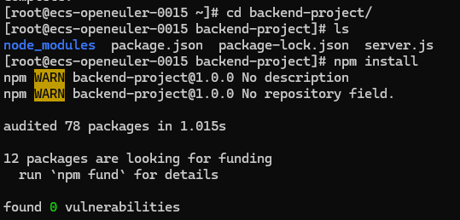Step 5: Navigate to the server.js folder and install all the dependencies

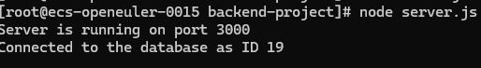Step 6: run the node server

Step 7: Testing with postman

